Title: | Practice LIN Protocol

History
Issue status  (Index) | Maturity/Date  (draft/invalid/valid)  (dd-mmm-yyyy) | Author  Department | Check/Release  Department | Description
1.0 | Draft  04-0ct-09 | Miguel Garcia | Miguel Garcia | Creation of the document
1.1 | 06-08-2015 | Hector Cuellar  Pedro Romero | Francisco | First Review

Table of Contents
1 Purpose 4
2 Definitions and abbreviations 4
3 Realization constraints and targets 4
4 SW CONCEPTUAL DESIGN 5
4.1 General Diagram 5
4.2 Uses Cases Diagram 6
4.3 Component Diagram 7
4.4 State Diagram 8
4.5 Diagram of the signal MASTER_CMD_ALL 9
4.6 Diagram of the signal MASTER_CMD_SLV2 9
4.7 Diagram of the signal SLAVE2_RSP 10
4.8 Diagram of the signal SLAVE2_ID 10
5 SW Component internal breakdown 11
5.1.1 Function void SLV2_StateFCN_IDLE (void) 12
5.1.2 Function void SLV2_StateFCN_ID (void) 12
5.1.3 Function void SLV2_StateFCN_Data_Rx (void) 12
5.1.4 Function void SLV2_StateFCN_Data_Tx (void) 13
5.1.5 Function void SLV2_StateFCN_CheckSum_Tx (void) 13
5.1.6 Function void SLV2_StateFCN_CheckSum_Rx (void) 13
5.1.7 Function void SLV2_StateFCN_Response_Rx (void) 14
5.1.8 Function void SLV2_StateFCN_Send_Tx (void) 14
5.2 Macros 14
5.3 SW module global variables 14
5.4 Design solutions for general features 15
5.5 SW Component integration 15
5.5.1 Integration context / constraints 15
5.5.2 Include files 15
5.5.3 Initialization 15
5.5.4 Interrupts 15
5.5.5 Real time scheduler task 15
5.5.6 Other entry points 15
5 SW Component internal breakdown 17
5.1 Functional Decomposition 17
5.1.1 Function void SLV2_StateFCN_IDLE (void) 18
5.1.2 Function void SLV2_StateFCN_ID (void) 18
5.1.3 Function void SLV2_StateFCN_ID (void) 18
5.2 Macros 18
5.3 SW module global variables 19
5.4 Design solutions for general features 19
5.5 SW Component integration 19
5.5.1 Integration context / constraints 19
5.5.2 Include files 19
5.5.3 Initialization 19
5.5.4 Interrupts 20
5.5.5 Real time scheduler task 20
5.5.6 Other entry points 20

Purpose
This document describes the LIN slave node implementation in the Freescale TRK-MPC5606B development board platform.
The LIN communication protocol is for low cost automotive networks

Definitions and abbreviations
Definitions
LIN | Local Interconnect Network
Rx  Tx  MSTR | Reception  Transmission  Master
SLV | Slave
MSG | Message
CMD  AVT | Command  Advanced Vehicle Technologies

References
N° | Document name | Reference
1  2 | LIN_Network_Database.xlsm  Requirement | Link  Link

Realization constraints and targets
- The master header will be provided by AVT model 718 using the SW tool Generic GUI
- This slave node will listen to all message that correspond at the slave 2
- If the message is MASTER_CMD_ALL the slave will execute the command, the command can be turn on led, turn off led , toggle led, do nothing, enable slave and disable slave (all slaves listen)
- If the message is MASTER_CMD_SLV2 the slave will execute the command, the command can be turn on led, turn off led , toggle led, do nothing, enable slave and disable slave
- If the message is SLAVE2_RSP the slave will publish the led status (on, off, toggle) and the state of the slave (Enable or Disable)
- If the message is SLAVE2_ID the slave will publish the slave2_supplier (in this case the number 2) and the slave2_serial (array with the abbreviation of the names of the team members)

SW CONCEPTUAL DESIGN

General Diagram
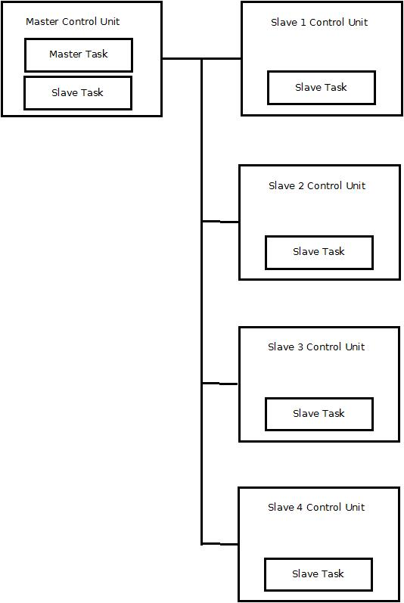

This diagram describe the general system with the master and the four slaves. This document only design the software for the slave 2.

Uses Cases Diagram
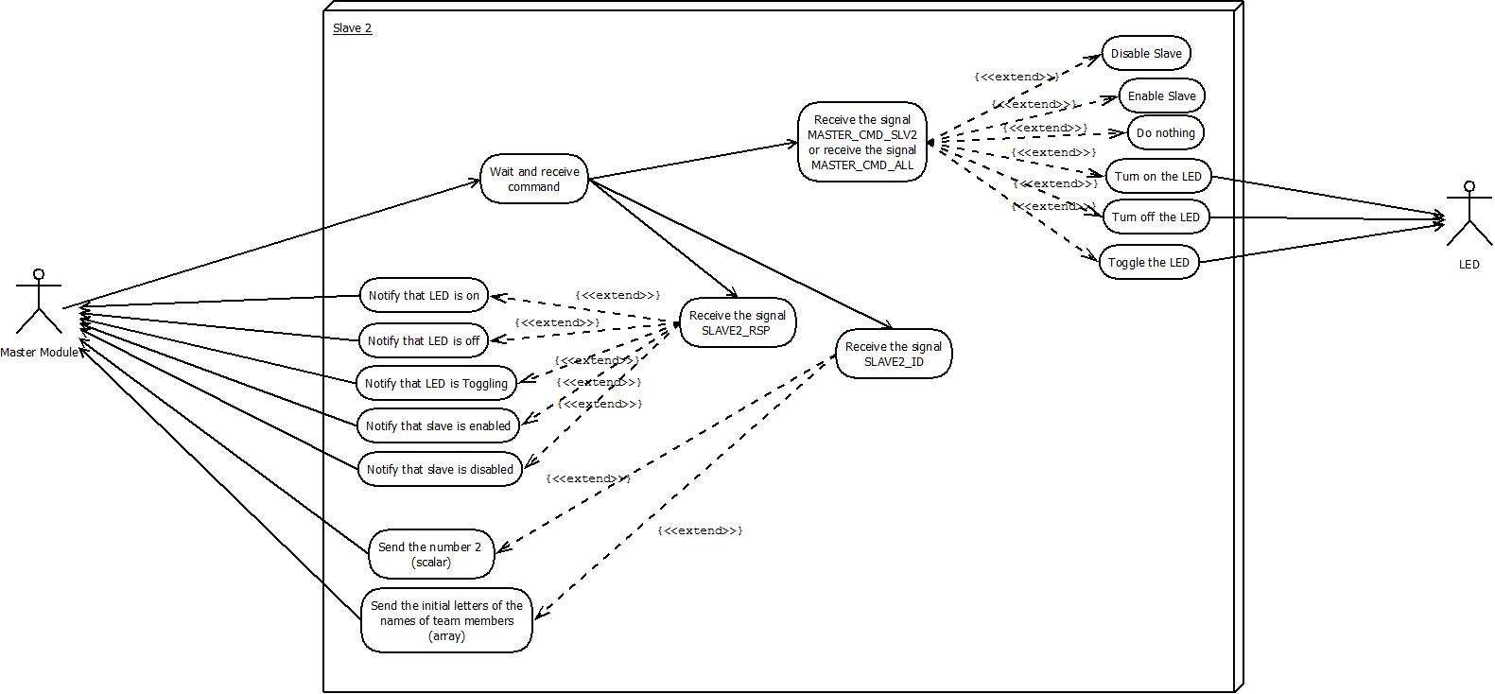

Sequence Diagram
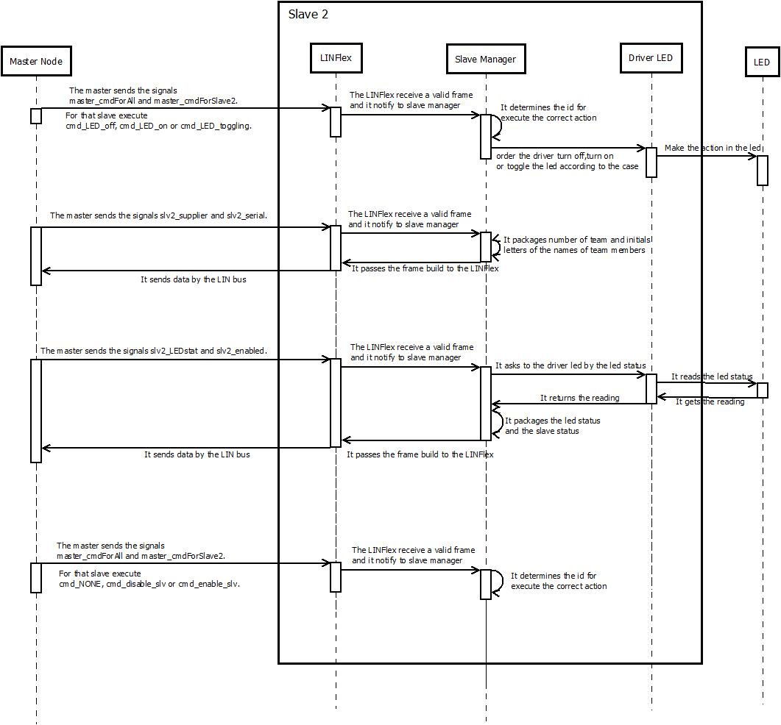

Component Diagram
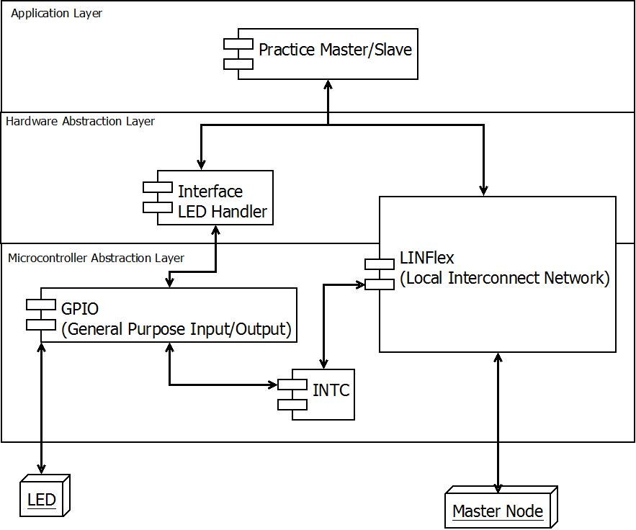

State Diagram
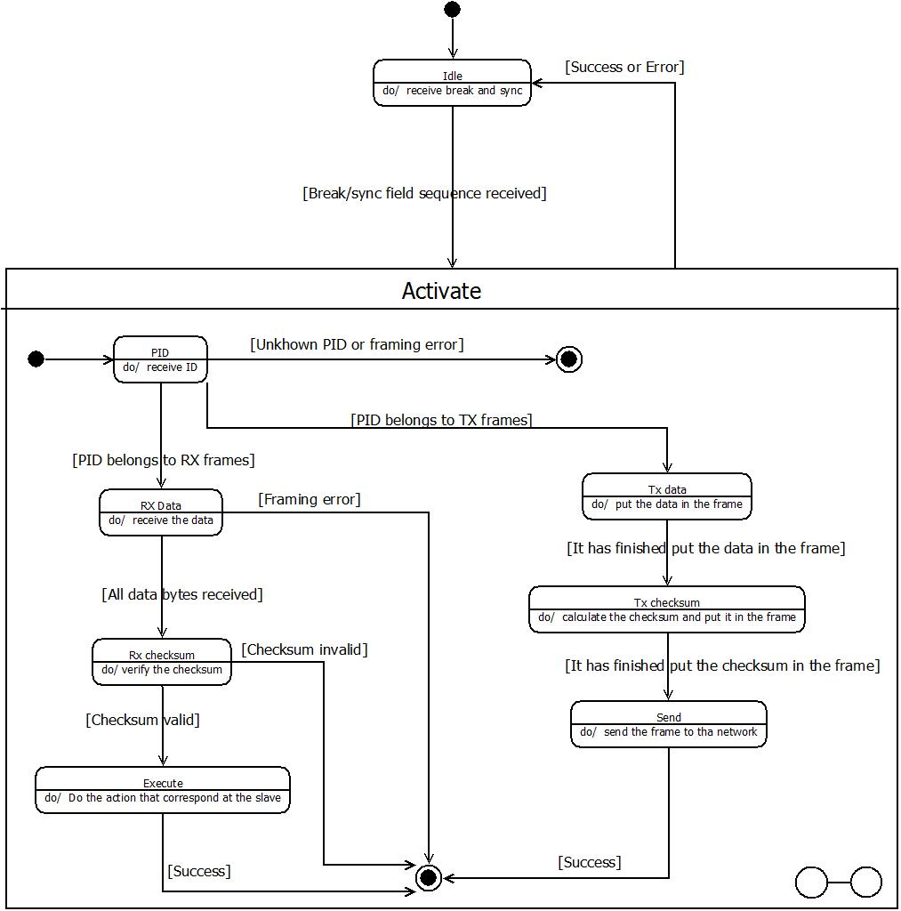

Diagram of the signal MASTER_CMD_ALL
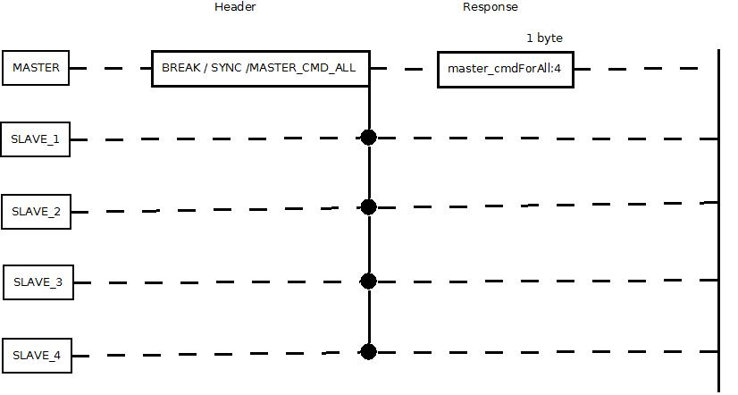

Diagram of the signal MASTER_CMD_SLV2
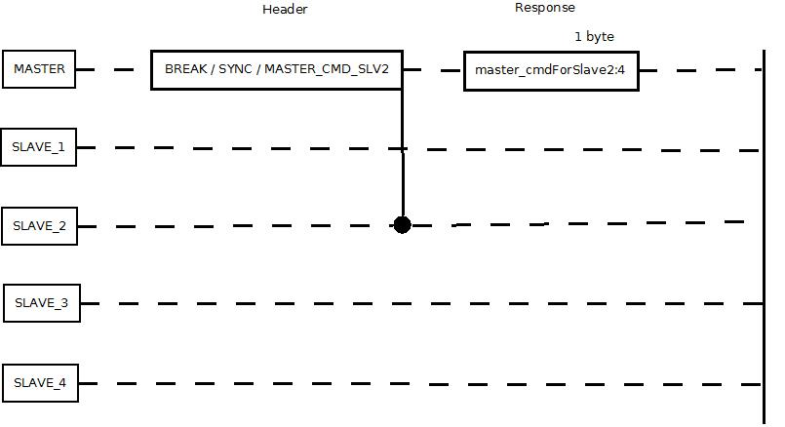

Diagram of the signal SLAVE2_RSP
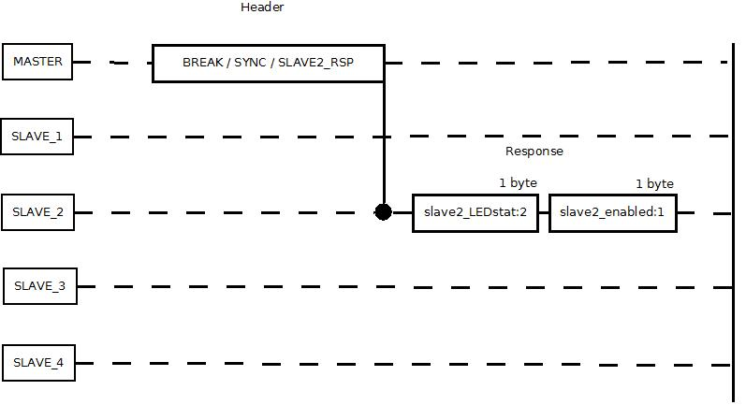

Diagram of the signal SLAVE2_ID
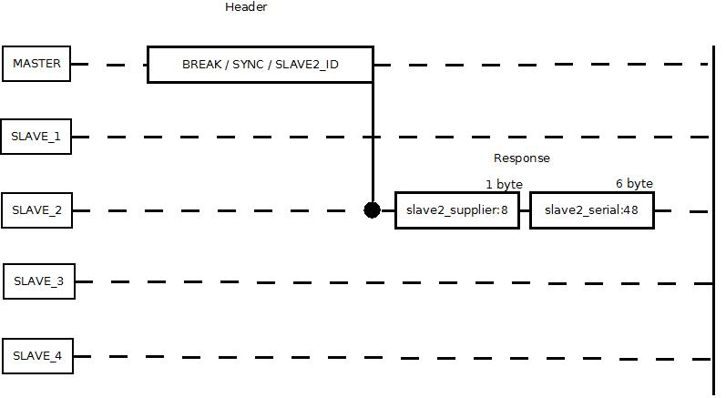

SW Component internal breakdown
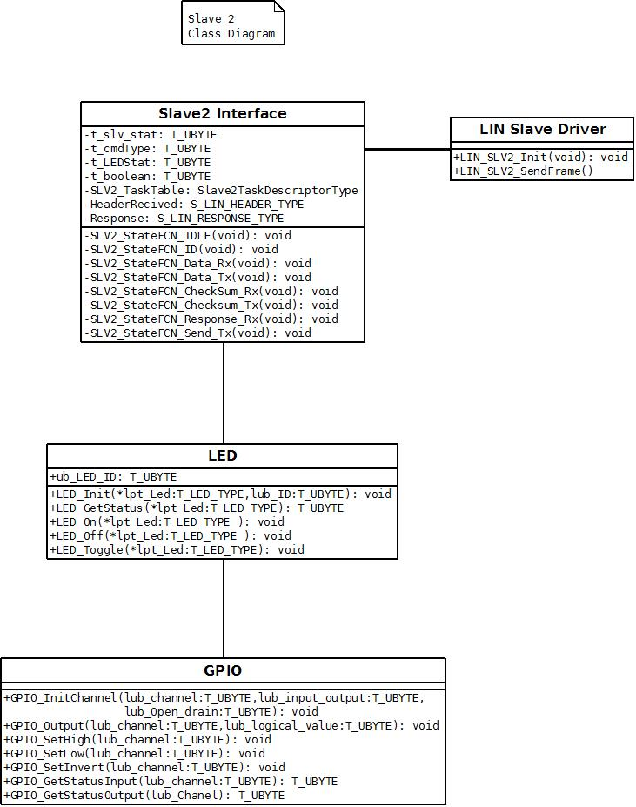

Function Description and Dynamic Behavior

Function void SLV2_StateFCN_IDLE (void)

Description | In this function state the slave is waiting for a header, and when a header has been published this function validate the break and the sync and go to the next state
Parameter 1 | Void
Return Value | Void
Precondition
Post condition | Activate some Functionality
Error Conditions

Dynamic Behavior

Function void SLV2_StateFCN_ID (void)

Description | This function takes the ID and check the parity if the message is valid, identify if the message is for this slave pass to the next state if not return to the state IDLE
Parameter 1 | Void
Return Value | Void
Precondition | Must pass first the state IDLE
Post condition | Go to state Data Rx or Tx
Error Conditions

Dynamic Behavior

Function void SLV2_StateFCN_Data_Rx (void)

Description | This function receive a buffer of data send by the master
Parameter 1 | Void
Return Value | Void
Precondition | This function state correspond when the message ID refers that the Data will be published by the master
Post condition | Go to state CheckSum Rx
Error Conditions

Dynamic Behavior

Function void SLV2_StateFCN_Data_Tx (void)

Description | This function creates a buffer of data to the master, depending on the master request
Parameter 1 | Void
Return Value | Void
Precondition | This function state correspond when the message ID refers that the Data will be published by the slave2
Post condition | Go to state CheckSum Tx
Error Conditions

Dynamic Behavior

Function void SLV2_StateFCN_CheckSum_Tx (void)

Description | This function Create a Checksum according to specifications of LIN 2.0 and is added to the buffer that contains the response
Parameter 1 | Void
Return Value | Void
Precondition | The previous state must be Data_Tx
Post condition | Go to state Send_Tx
Error Conditions

Dynamic Behavior

Function void SLV2_StateFCN_CheckSum_Rx (void)

Description | This function validate the Checksum according to specifications of LIN 2-0, and if it is correct proceed to the next state, If not the buffer that contains the response must be ignored
Parameter 1 | Void
Return Value | Void
Precondition | The previous state must be Data_Rx
Post condition | Go to state Response_Rx
Error Conditions

Dynamic Behavior

Function void SLV2_StateFCN_Response_Rx (void)

Description | The function execute the command received in the buffer
Parameter 1 | Void
Return Value | Void
Precondition | The Checksum must be correct
Post condition | Go to state IDLE
Error Conditions

Dynamic Behavior

Function void SLV2_StateFCN_Send_Tx (void)

Description | This function send the response to the LIN bus, so the Master will listen
Parameter 1 | Void
Return Value | Void
Precondition | The Checksum must be correct
Post condition | Go to state IDLE
Error Conditions

Dynamic Behavior

Macros

Only complex macros shall be described here. A complex macro is longer then one line or has more then one parameter or command. A complete description of all macros shall be done by code comments.
Be aware: macros shouldn’t be part of the interface: Don’t use macros at interface level!
If you still think you need macros: document them like functions.
Internal Interfaces
For internal interaction a data flow and/or a message sequence chart shall be provided. If the Static Function Tree already contains a data flow description then just reference it

SW module global variables
Where shared variables can not be avoided, a risk analysis is mandatory.
Name | Type | Memory section | Description | Shared
Klstrg_status | T_UBYTE | NON_INIT_RAM | Status of terminal control | X

Design solutions for general features
It should describe detailed design solutions for general features of our products. i.e ”Layer Programming”

SW Component integration

Integration context / constraints
Tbd: help text

Include files
List here the necessary include files and their order,

Initialization
e.g. Sequence Chart for initialization
All function bellow shall be called on initialization
Call Order | Service | Call constraints linked to an other module
1 | BCM_Warning_Output_Init_Function | After EEPROM init

Interrupts
If described in the SW Architecture Document, just put the reference here.

Real time scheduler task
If described in the SW Architecture Document, just put the reference here.

Other entry points
Name | Service | Task level

SW Component internal breakdown
For complex SW Components, the designer may define SW Subcomponents. Please consider also the work step "Deal with complexity" provided by the method for Detailed SW Design.
Note: SW Subcomponents are synonymous with the previous used term "Module"
Mapping to the file structure:
- Non complex SW Components should be represented by one object file.
- For complex SW Components each SW Subcomponent should be represented by one object file.
<Subcomponent decomposition if applicable>

Functional Decomposition
Overview of functions and their dependencies shown by a Static Function Tree
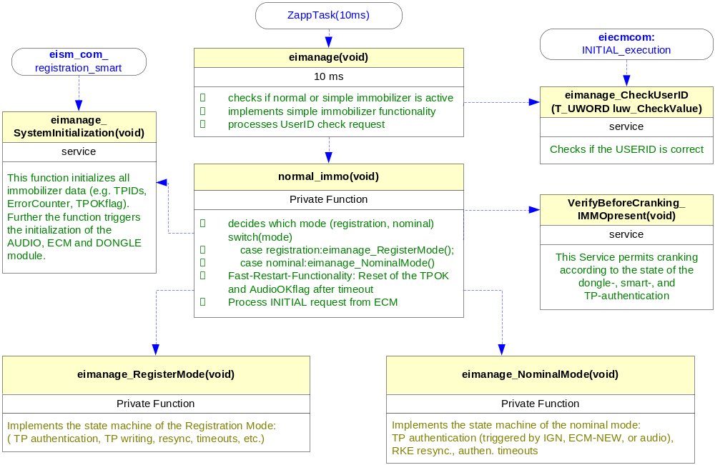
Function Description and Dynamic Behavior

Function void SLV2_StateFCN_IDLE (void)

Description | In this function state the slave is waiting for a header, and when a header has been published this function validate the break and the sync and go to the next state
Parameter 1 | Void
Return Value | Void
Precondition
Post condition | Activate some Functionality
Error Conditions

Dynamic Behavior

Function void SLV2_StateFCN_ID (void)

Description | This function takes the ID and check the parity if the message is valid, identify if the message is for this s
Parameter 1 | Void
Return Value | Void
Precondition | Must pass first the state IDLE
Post condition | Go to state Data Rx o Tx
Error Conditions

Dynamic Behavior

Function void SLV2_StateFCN_ID (void)

Description | In this function state the slave is waiting for a
Parameter 1 | Void
Return Value | Void
Precondition | Must pass first the state IDLE
Post condition | Go to state Data Rx o Tx
Error Conditions

Dynamic Behavior

Macros

Only complex macros shall be described here. A complex macro is longer then one line or has more then one parameter or command. A complete description of all macros shall be done by code comments.
Be aware: macros shouldn’t be part of the interface: Don’t use macros at interface level!
If you still think you need macros: document them like functions.
Internal Interfaces
For internal interaction a data flow and/or a message sequence chart shall be provided. If the Static Function Tree already contains a data flow description then just reference it

SW module global variables
Where shared variables can not be avoided, a risk analysis is mandatory.
Name | Type | Memory section | Description | Shared
Klstrg_status | T_UBYTE | NON_INIT_RAM | Status of terminal control | X

Design solutions for general features
It should describe detailed design solutions for general features of our products. i.e ”Layer Programming”

SW Component integration

Integration context / constraints
Tbd: help text

Include files
List here the necessary include files and their order,

Initialization
e.g. Sequence Chart for initialization
All function bellow shall be called on initialization
Call Order | Service | Call constraints linked to an other module
1 | BCM_Warning_Output_Init_Function | After EEPROM init

Interrupts
If described in the SW Architecture Document, just put the reference here.

Real time scheduler task
If described in the SW Architecture Document, just put the reference here.

Other entry points
Name | Service | Task level

